ENERGOMAG 2-CF

**Solid wire, copper free**

|  |  |  |  |
| --- | --- | --- | --- |
| **Classifications** | DIN 8559 | EN ISO 14341-A | AWS A 5.18 |
|  | SG2 | G42 4 C1/M21 3 Si1 | ER 70S-6 |

**Description** Copper free solid wire for welding unalloyed and low alloy steels with CO2 or gas mixture. Promotes a low sensitivity to surface impurities and contributes to smooth welding. Reduced contact tip wear is observed as well as improved protection against corrosion. Used in general construction, shipbuilding and automotive components. Especially dedicated to mechanised welding processes. Provides stable arc, low level of spatter and low fume emission.

**Base materials** Steels with a yield strength ≥420 MPa

S235JR-S355JR, S235JO-S355JO, S235J2-S355J2, S275N-S420N, S275M- S420M, P235GH-P355GH, P275NL1-P355NL1, P215NL, P265NL, P355N, P285NH-P420NH, P195TR1-P265TR1, P195TR2-P265TR2, P195GH-P265GH, L245NB-L415NB, L245MB-L415MB, GE200-GE240,

ship building steels: A, B, D, E, A 32-E 36

|  |  |  |  |  |  |  |
| --- | --- | --- | --- | --- | --- | --- |
| **Typical composition** | C | Si | Mn | S | P | Cu |
| **of solid wire (%)** | 0,06-0,14 | 0,7-1,0 | 1,3-1,6 | ≤0,025 | ≤0,025 | ≤0,35 |

|  |  |  |  |  |
| --- | --- | --- | --- | --- |
| **Mechanical properties**  **of all-weld metal** | Yield  strength | Tensile  strength | Elongation  (L0 = 5d0) | Impact values  in J CVN |
| (acc. to EN 15792-1, | 0,2% N/mm2 | N/mm2 | % | -40 o C |
| shielding gas M21) | ≥ 420 | 500-640 | ≥ 20 | ≥ 47 |

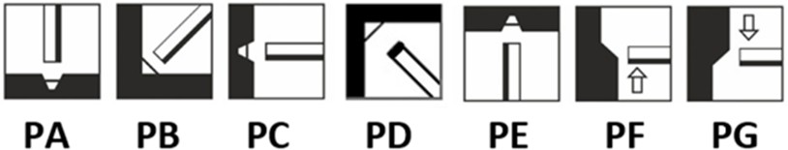**Welding positions**

Polarity =+

Shielding gases: (EN ISO 14175: M2, M3, C)

**Dimensions (mm)** 0,6-1,6

**Spool /packing** 15kg spools BS300 / 250kg drum

**Certificates** CE, TÜV, DB

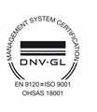thyssenkrupp Materials Poland S.A., ul. Grudziądzka 159, 87-100 Toruń

P: +48 56 611 94 94, F: +48 56 611 95 75, [biuro@tkmaterials.pl,](mailto:biuro@tkmaterials.pl) [www.thyssenkrupp-materials.pl](http://www.thyssenkrupp-materials.pl/) Zarząd: Ryszard Bojarski, Robert Buchnajzer, Roman Czyżykowski

NIP: 9561627586 REGON: 870422397

Sąd Rejonowy w Toruniu VII Wydział Gospodarczy Krajowego Rejestru Sądowego, Numer KRS: 20529 BH w Warszawie S.A. O/Bydgoszcz, Filia Toruń, konto nr: 61 1030 1090 0000 0000 0136 9501